Applied Statistical Analysis I: Problem Set One

Sophie McDonnell

15328561

Question One:

Part 1:

Code:

plot(density(y))

qqnorm(y)

qqline(y, distribution = qnorm)

CI_lower <- qnorm(0.05,

mean = mean(y),

sd = (sd(y)/sqrt(length(y))))

CI_upper <- qnorm(0.95,

mean = mean(y),

sd = (sd(y)/sqrt(length(y))))

matrix(c(CI_lower, CI_upper), ncol = 2,dimnames = list("",c("Lower", "Upper")))

var.test(y, ratio = 1, alternative = "two.sided", conf.level = 0.95)

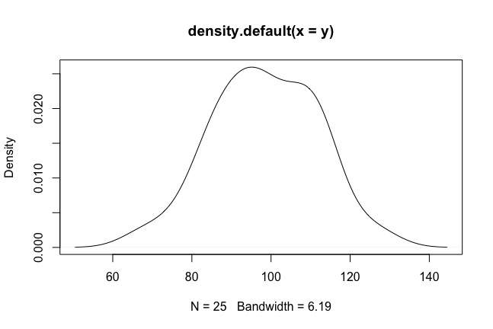

Confidence interval: Lower: 94.13283 Upper: 102.7472

Difference between Average IQ and National Average IQ are not statistically significant.

Question two:

Part 1:

Code:

expenditure <- read.table("~/Documents/GitHub/StatsI_Fall2022/datasets/expenditure.txt", header=T)

plot(expenditure$X1, expenditure$Y)

plot(expenditure$X2, expenditure$Y)

plot(expenditure$X3, expenditure$Y)

X1 and Y:

Per capita expenditure on shelters/housing assistance in state (Y) and per capita personal income in state (X1) has a positive linear moderate correlation.

X2 and Y:

Per capita expenditure on shelters/housing assistance in state (Y) and the number of residents per 100,00 that are financially insecure in state (X2) has a positive, non-linear relationship (potentially quadratic).

X3 and Y:

Per capita expenditure on shelters/housing assistance in state (Y) and the number of residents per thousand residing in urban areas has a positive, linear, moderate correlation.

Part Two:

Code:

boxplot(Y~Region, data=expenditure)

means <- tapply(expenditure$Y, expenditure$Region, mean)

points(means, col="red", pch=18)

means

On average, Region 4 has the highest per capita expenditure on housing assistance, with about 88.3 $ per capita.

Part Three:

Code:

plot(expenditure$X1, expenditure$Y, col=expenditure$Region, pch=expenditure$Region)

legend("topleft", legend=1:4, col=1:4, pch=1:4)

